AAW

AWS ADVANCED ASSIGNMENT-3

DAY 7-8

ARAVIND G KUMAR

**Project 1: VPC PEERING**

Task 1: Create first VPC

* Go to VPC from service tab.
* Select your VPC.
* Give IPv4 CIDR block as 172.19.0.0/16.
* Create VPC .

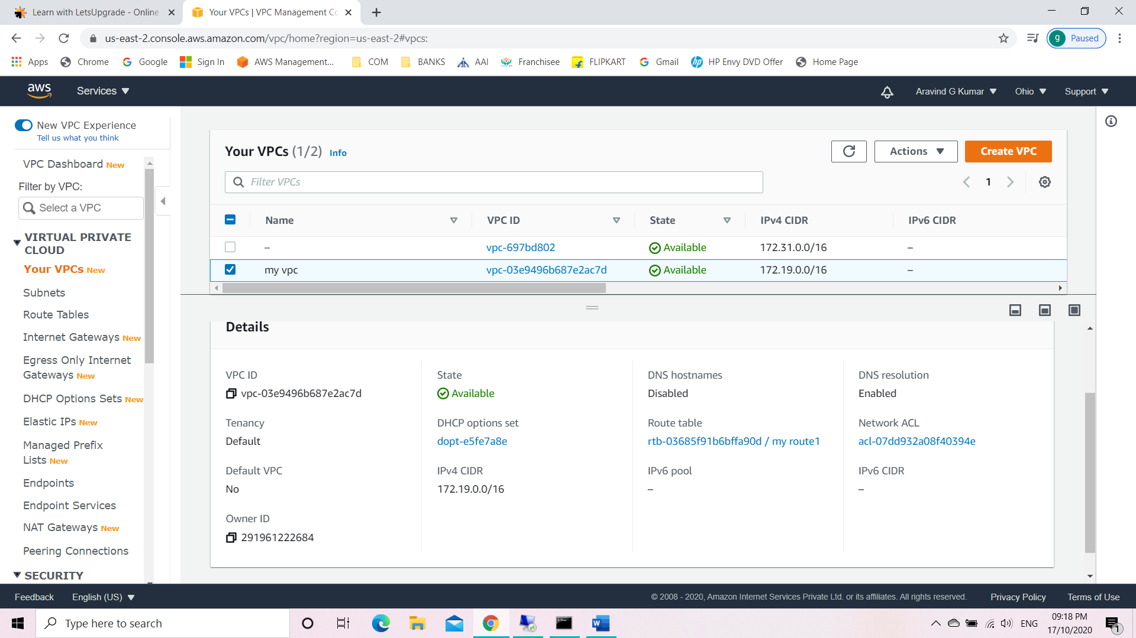

Task 2: Create an Internet gateway.

* Select internet gateway.
* Create internet gateway 1.
* Attach the internet gateway to the created VPC.

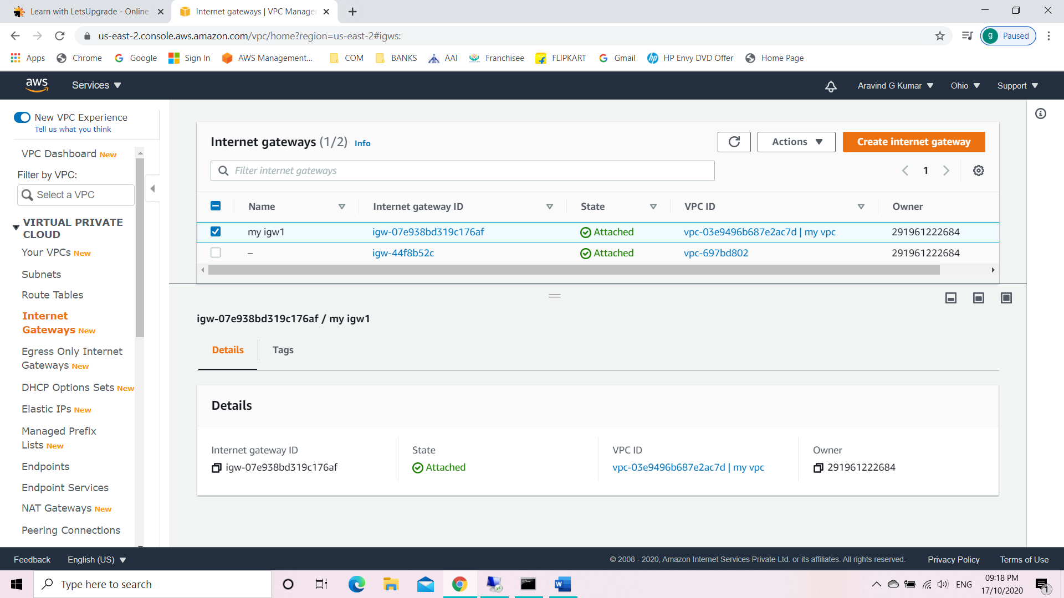

Task 3: Create a route table

* Select route table.
* Create route table 1.
* Click on edit routes.
* Add route like 0.0.0.0/0.
* Select set main route table.

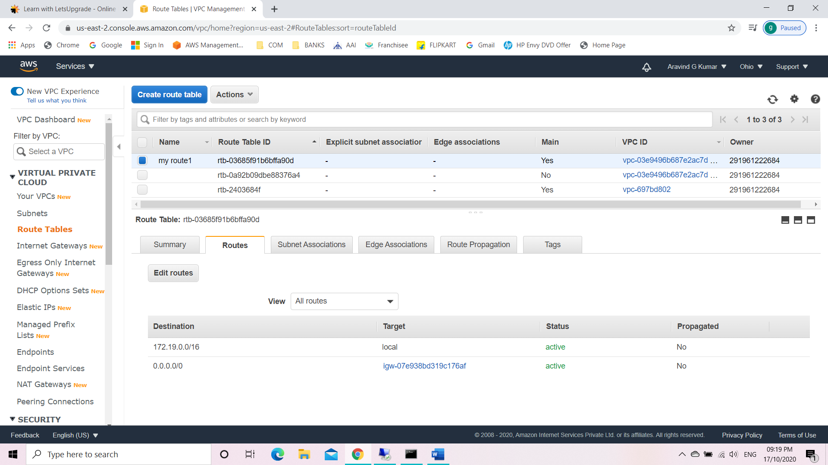

Task 4: Create a subnet

* Select subnet.
* Create subnet.
* Edit IPv4 CIDR block to 172.19.19.0/24.
* Modify auto assign.
* Enable auto assign IPv4.

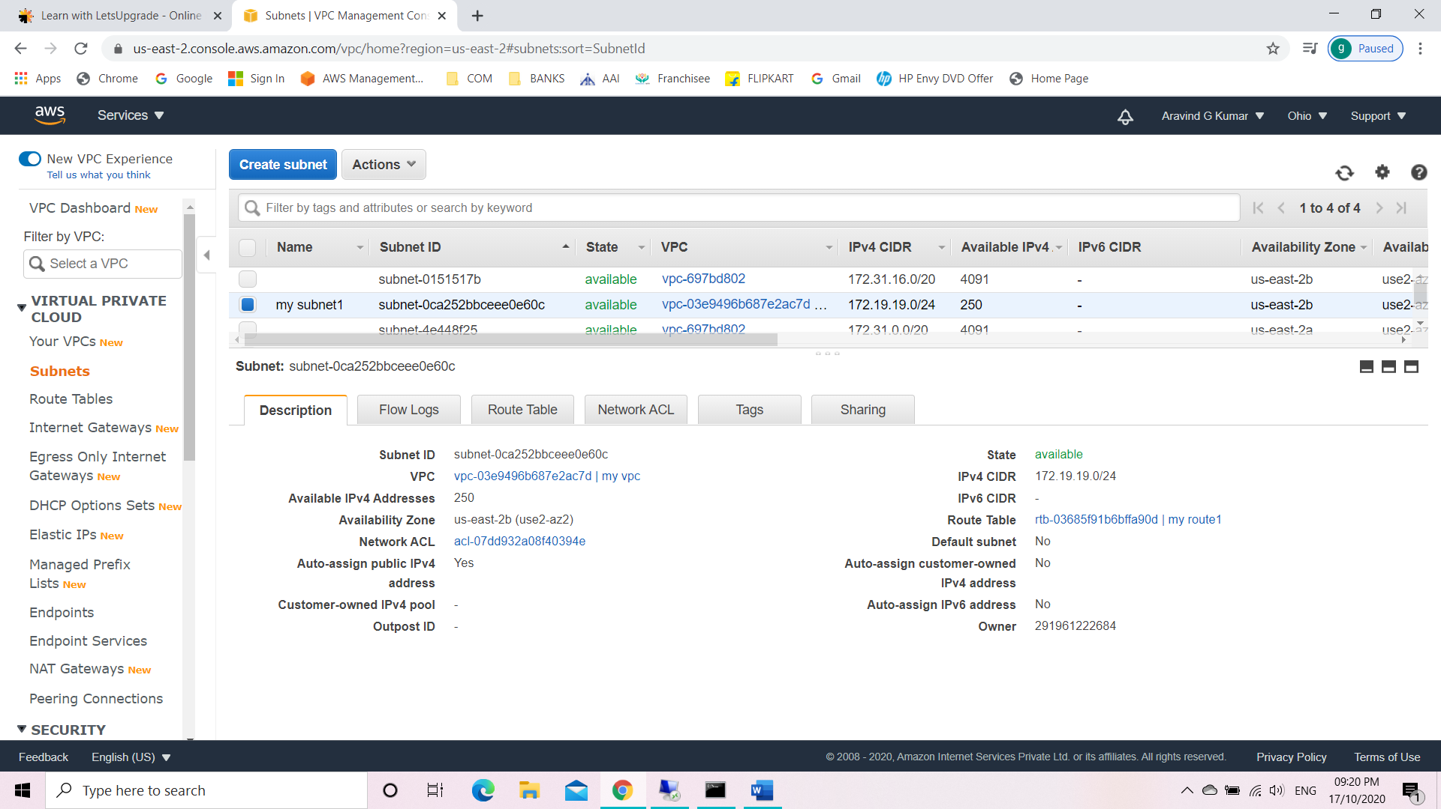

Task 5: Create an EC2 with custom VPC.

* Create a windows instance.
* Add the created VPC.

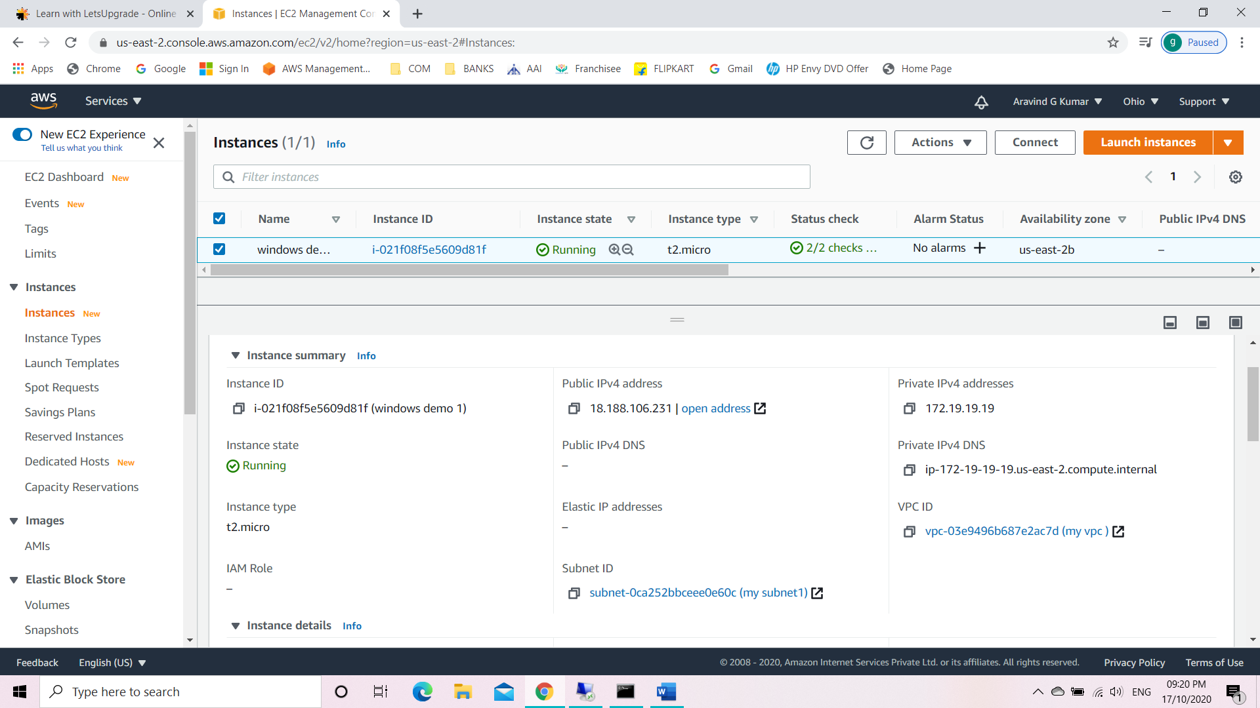

Task 6: Pinging from the base machine to the virtual machine with Public IPv4 using command prompt.

The base machine wasn’t able to ping the virtual machine.

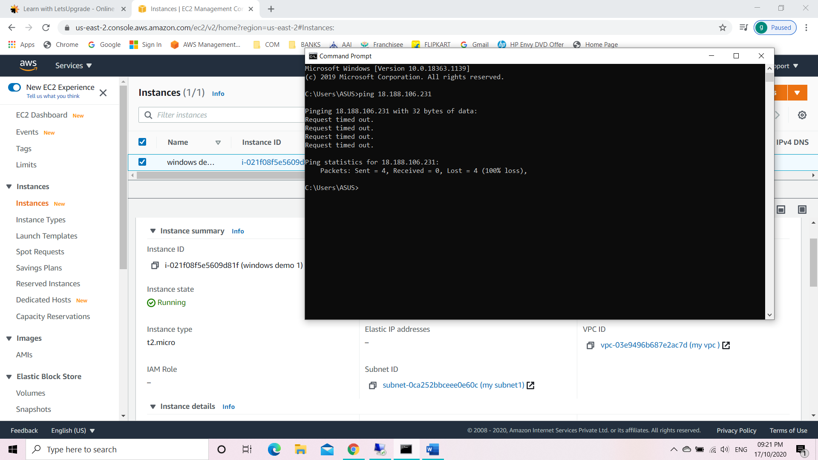

Task 7: Activate Echo request ICMPv4-IN.

* In the virtual machine open Windows Defender Firewall with Advanced Security.
* Go to inbound rules.
* Locate files and printers sharing (ICMPv4) and enable it.

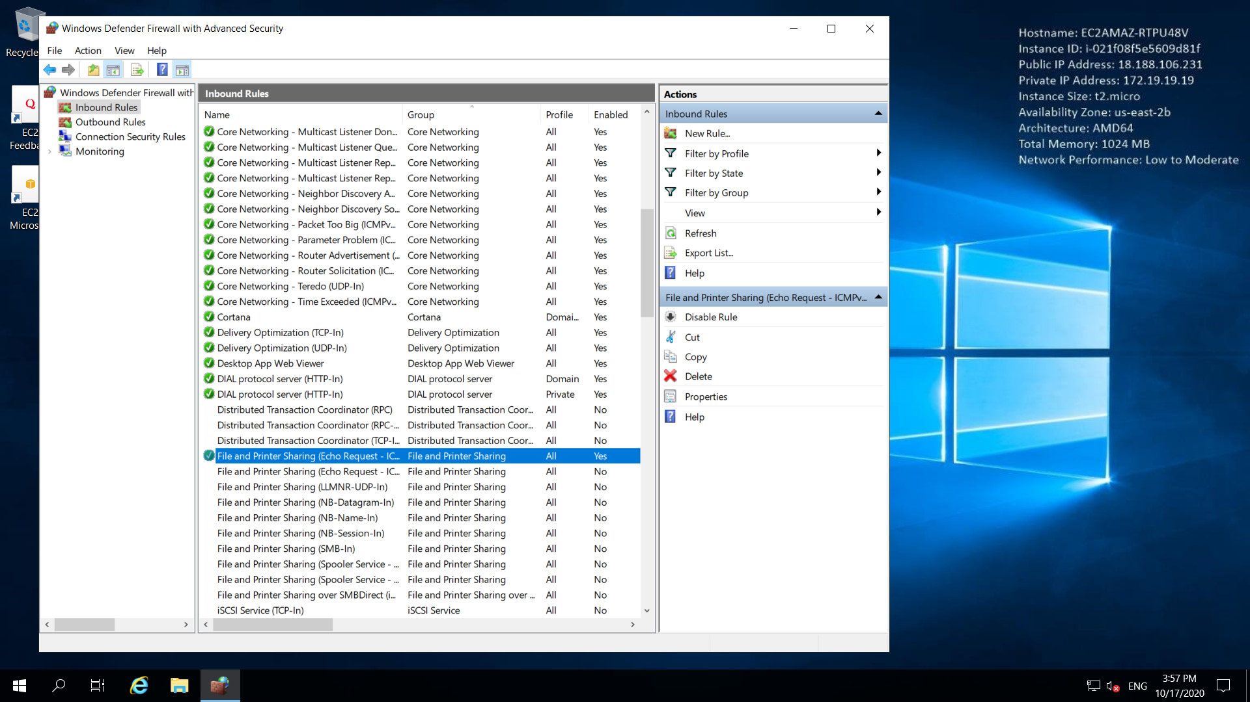

Task 8: Pinging from the base machine to the virtual machine with Public IPv4 using command prompt.

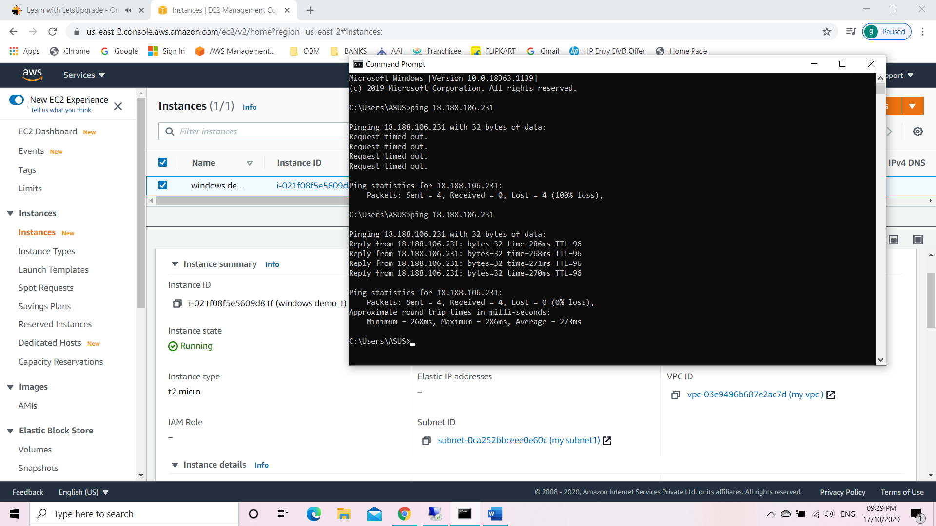

Task 9: Create second VPC

* Go to VPC from service tab.
* Select your VPC.
* Give IPv4 CIDR block as 172.16.0.0/16
* Create VPC 2.

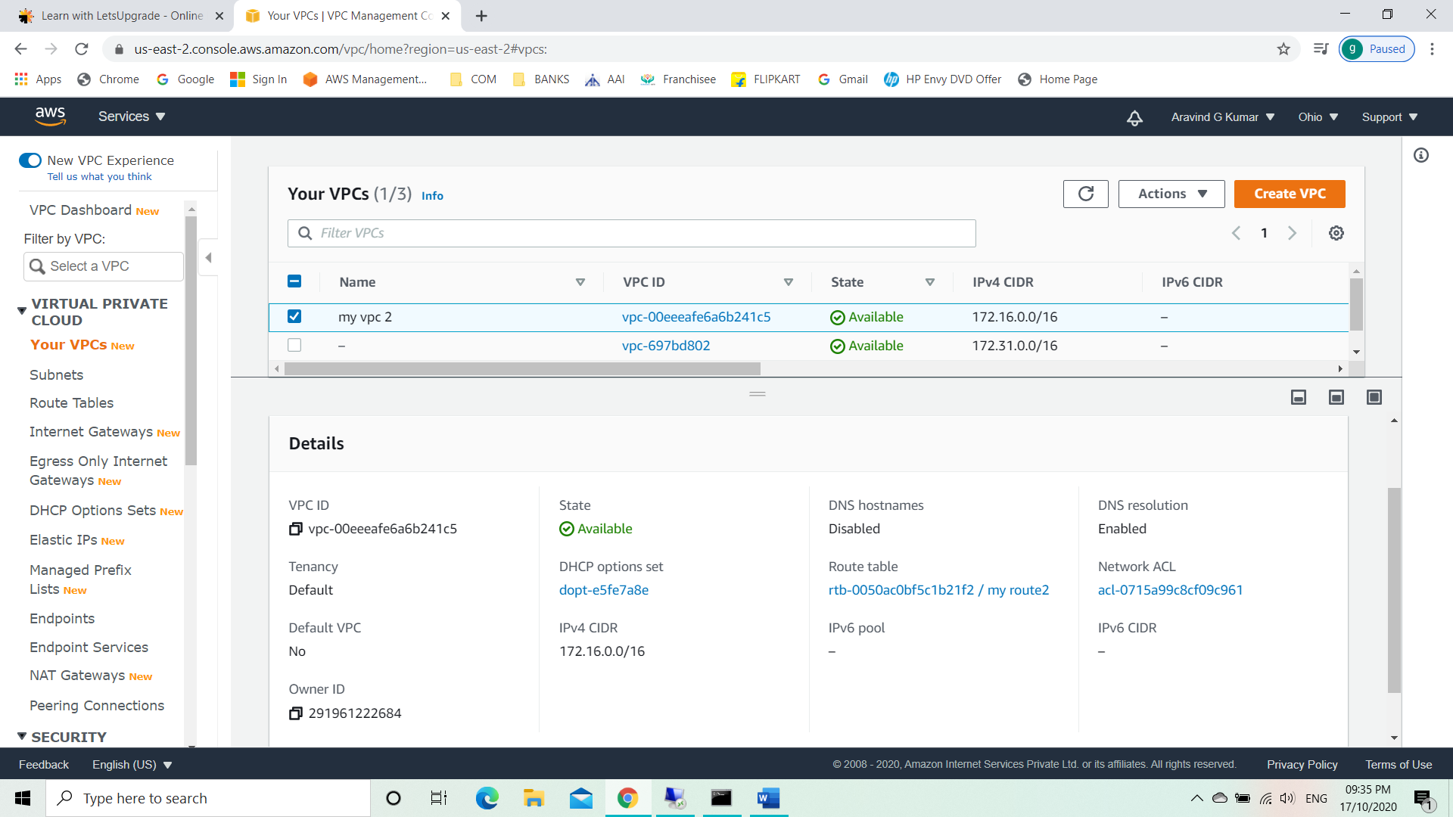

Task 10: Create an Internet gateway.

* Select internet gateway.
* Create internet gateway 2.
* Attach the internet gateway to the created VPC.

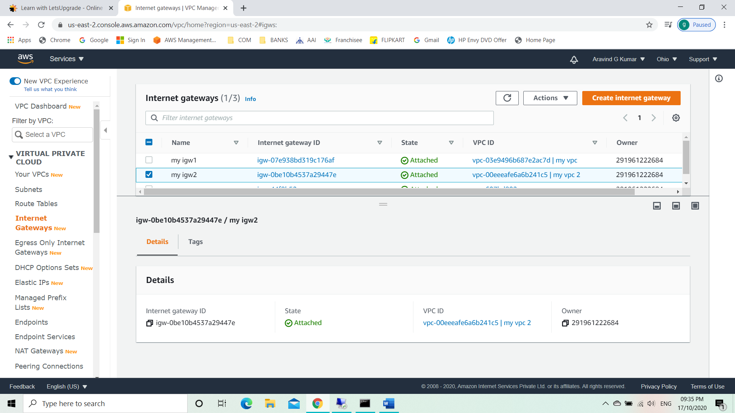

Task 11: Create a route table

* Select route table.
* Create route table 2.
* Click on edit routes.
* Add route like 0.0.0.0/0.
* Select set main route table.

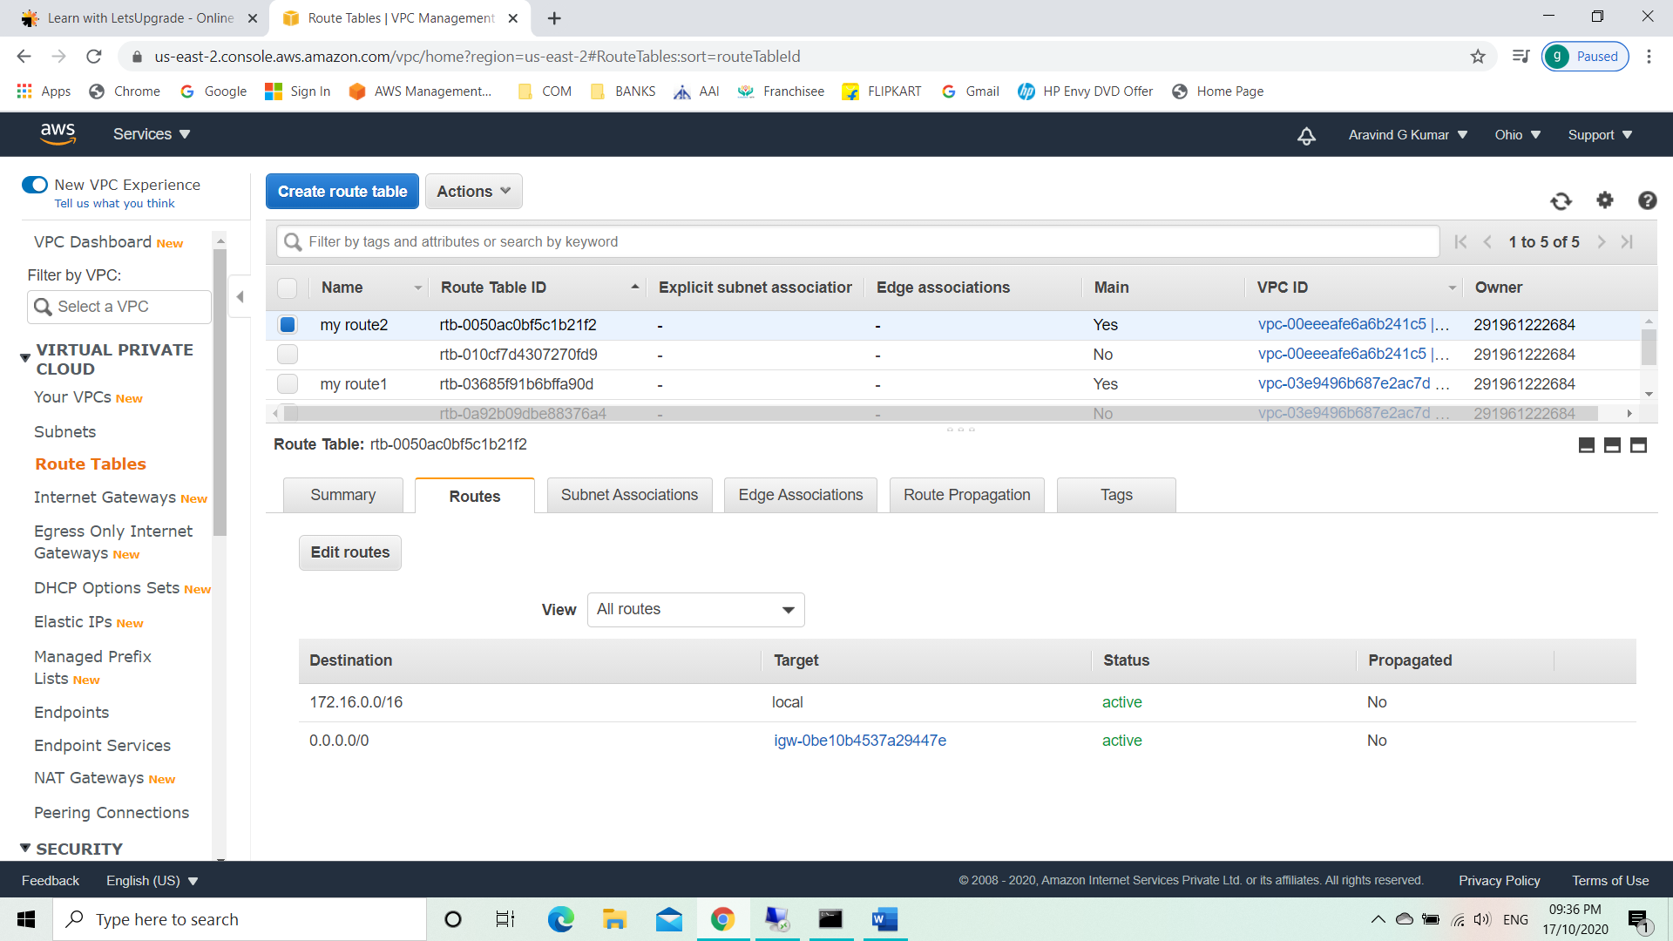

Task 12: Create a subnet

* Select subnet.
* Create subnet 2.
* Edit IPv4 CIDR block to 172.16.16.0/24.
* Modify auto assign.
* Enable auto assign IPv4.

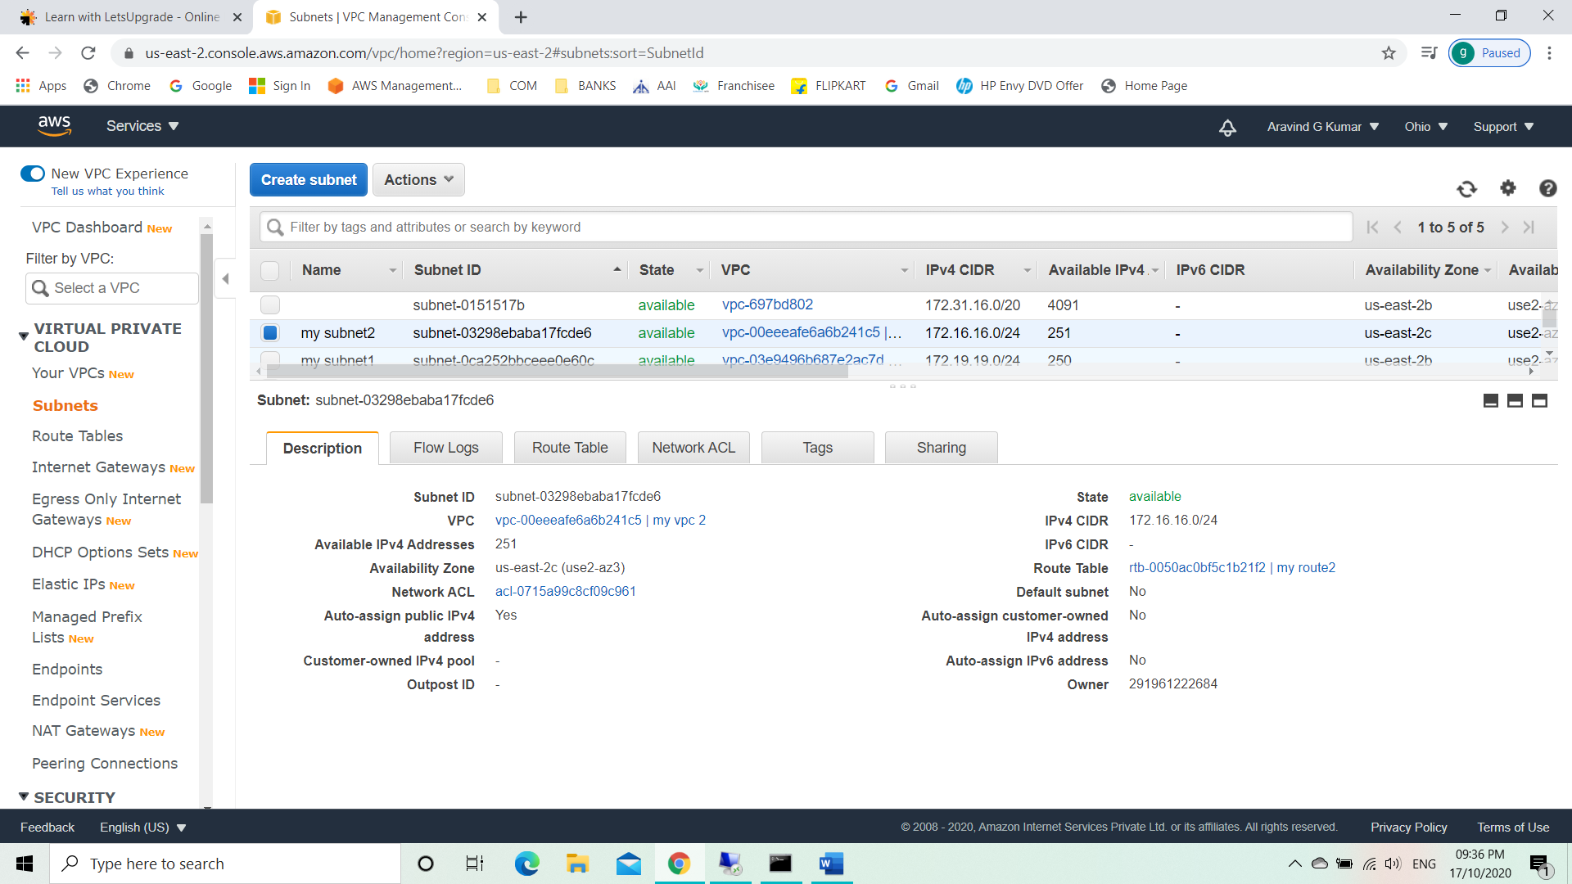

Task 13: Create an EC2 with custom VPC.

* Create a windows instance 2.
* Add the created VPC.

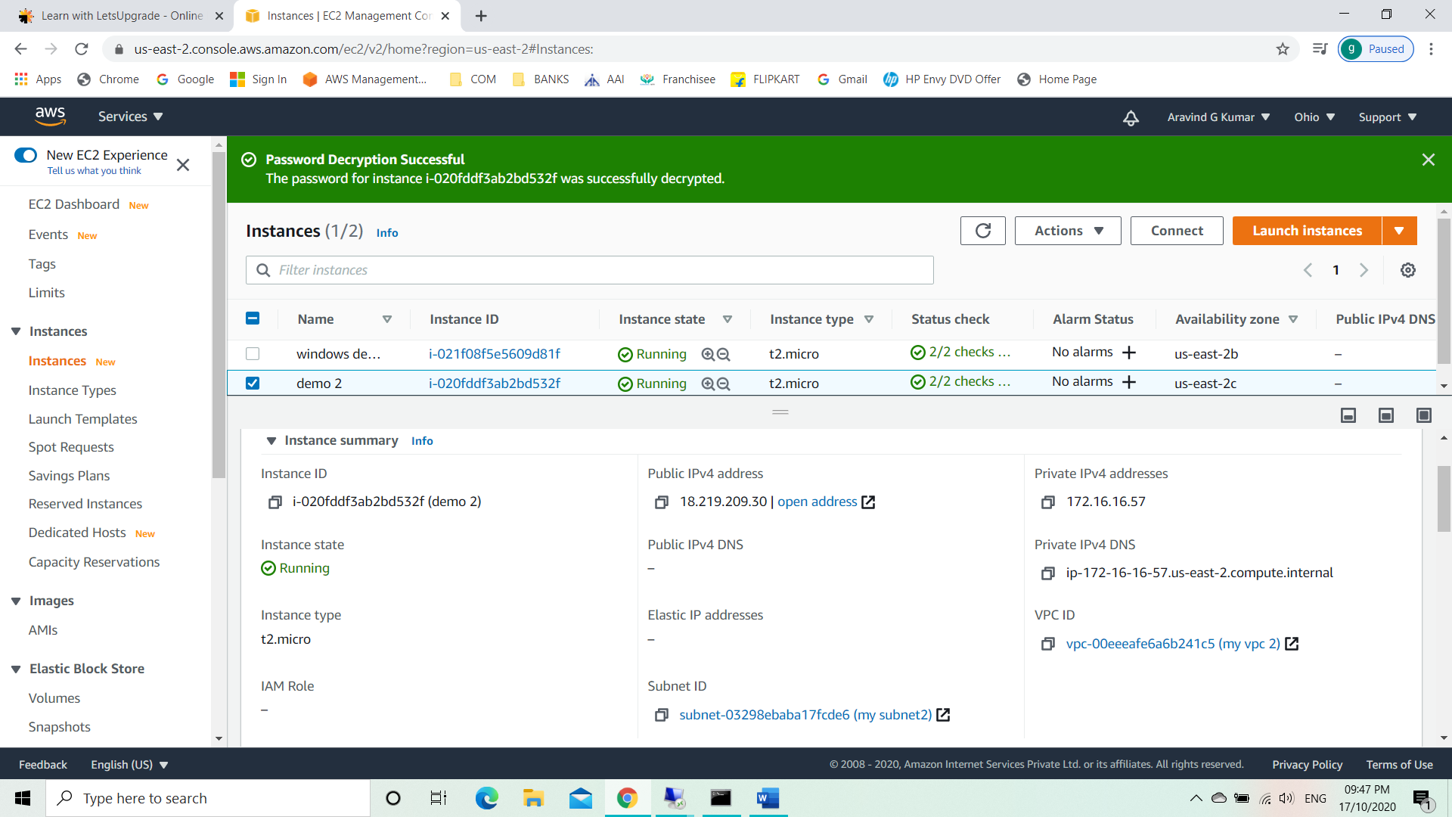

Task 14: Activate Echo request ICMPv4-IN.

* In the virtual machine open Windows Defender Firewall with Advanced Security.
* Go to inbound rules.
* Locate files and printers sharing (ICMPv4) and enable it.

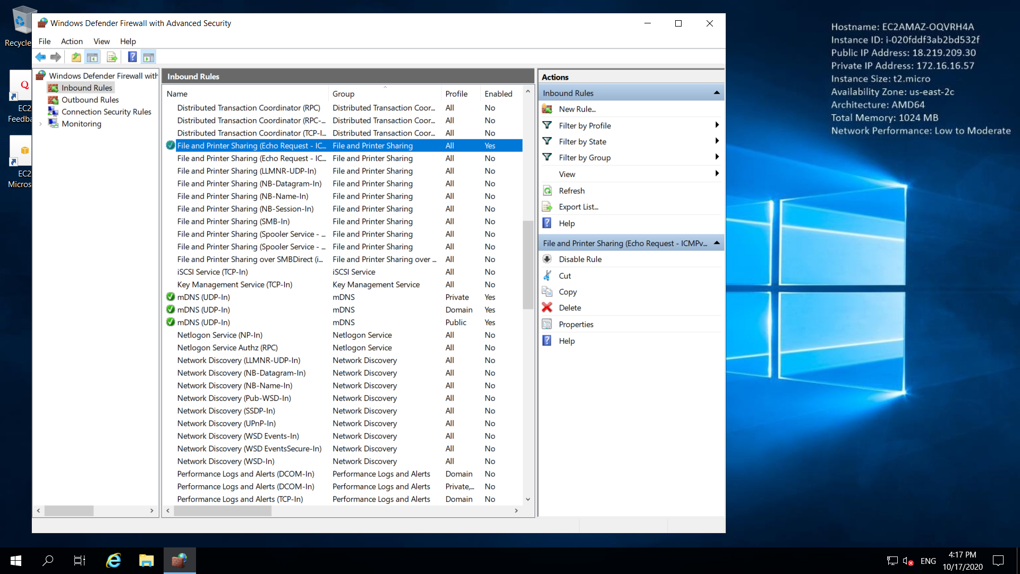

Task 15: Pinging from the base machine to the virtual machine with Public IPv4 using command prompt.

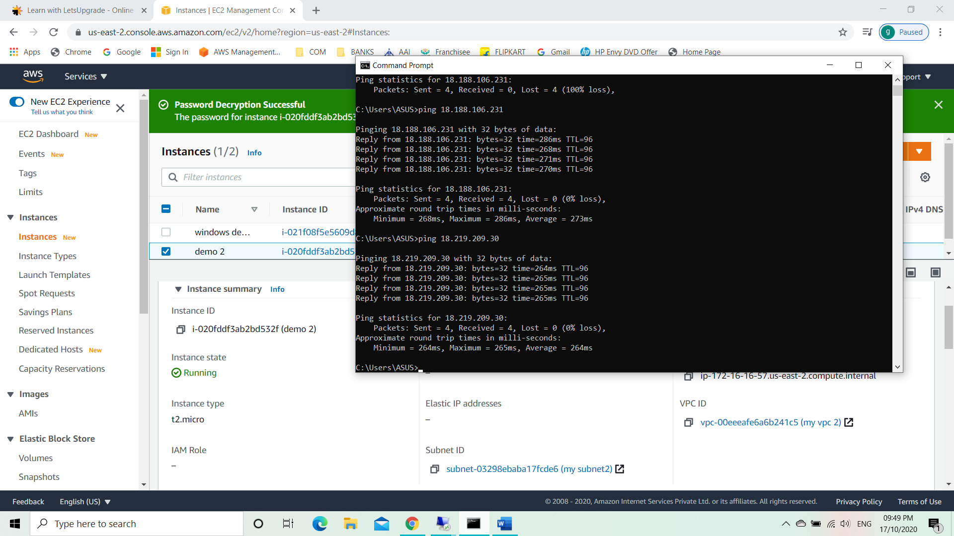

Task 16: Pinging between two virtual instances.

Pinging demo 1 to demo 2 virtual machines using Public IPv4.

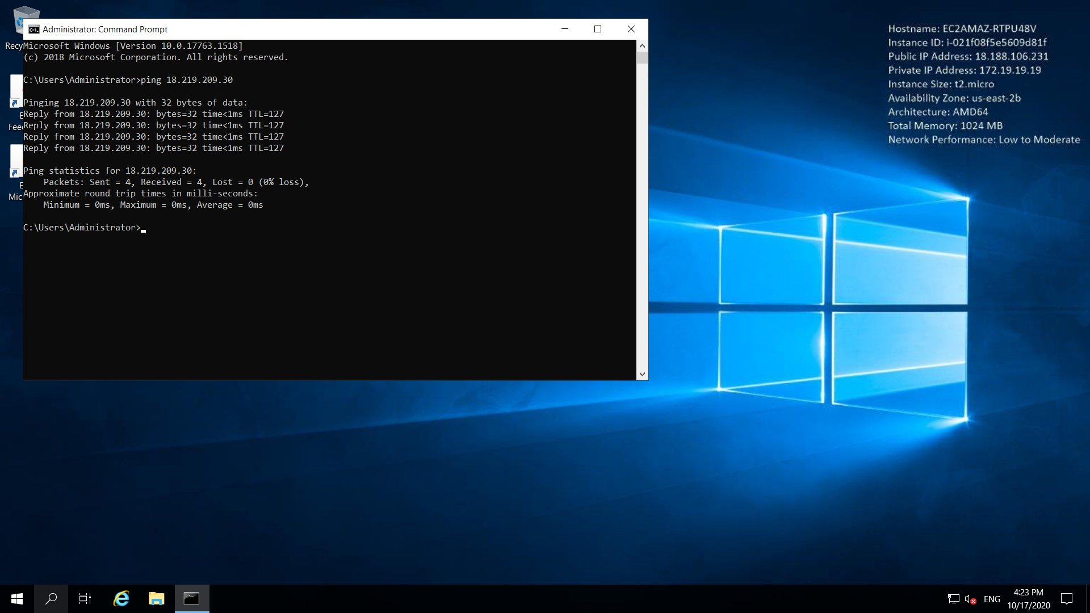

Pinging demo 1 to demo 2 virtual machines using Private IPv4. Error occurred.

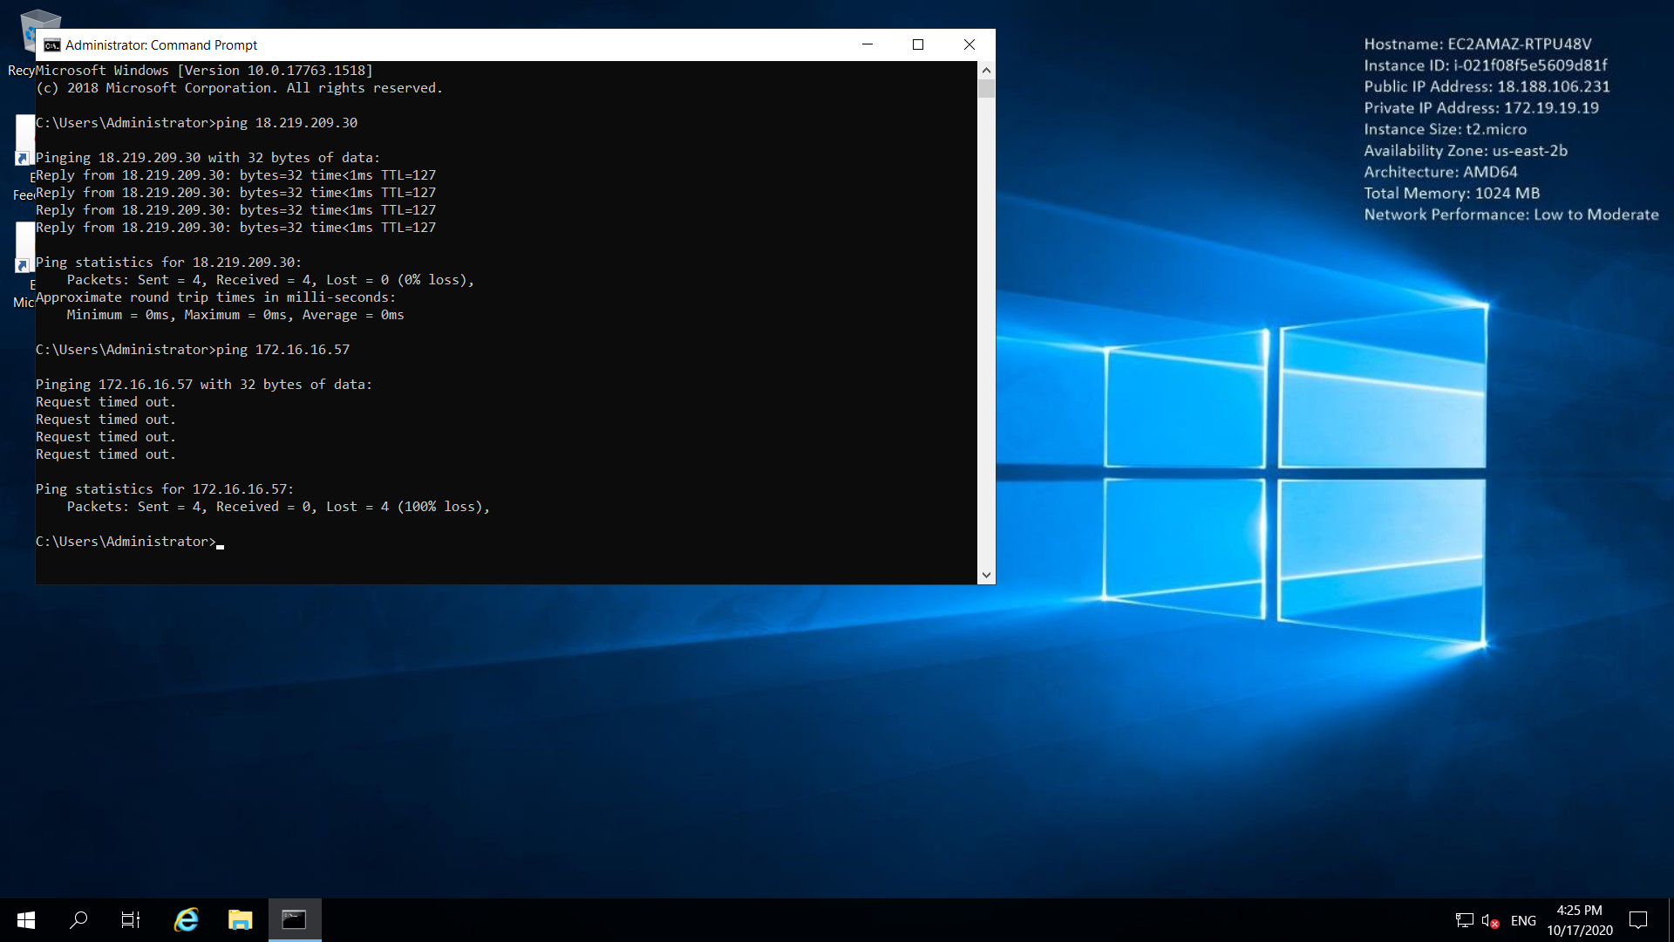

Task 17: Create a Peering connection.

* Go to peering connection in VPC from service menu.
* Create peering connection.
* Select VPC requester as demo 1.
* Select VPC accepter as demo 2.
* Create peer.

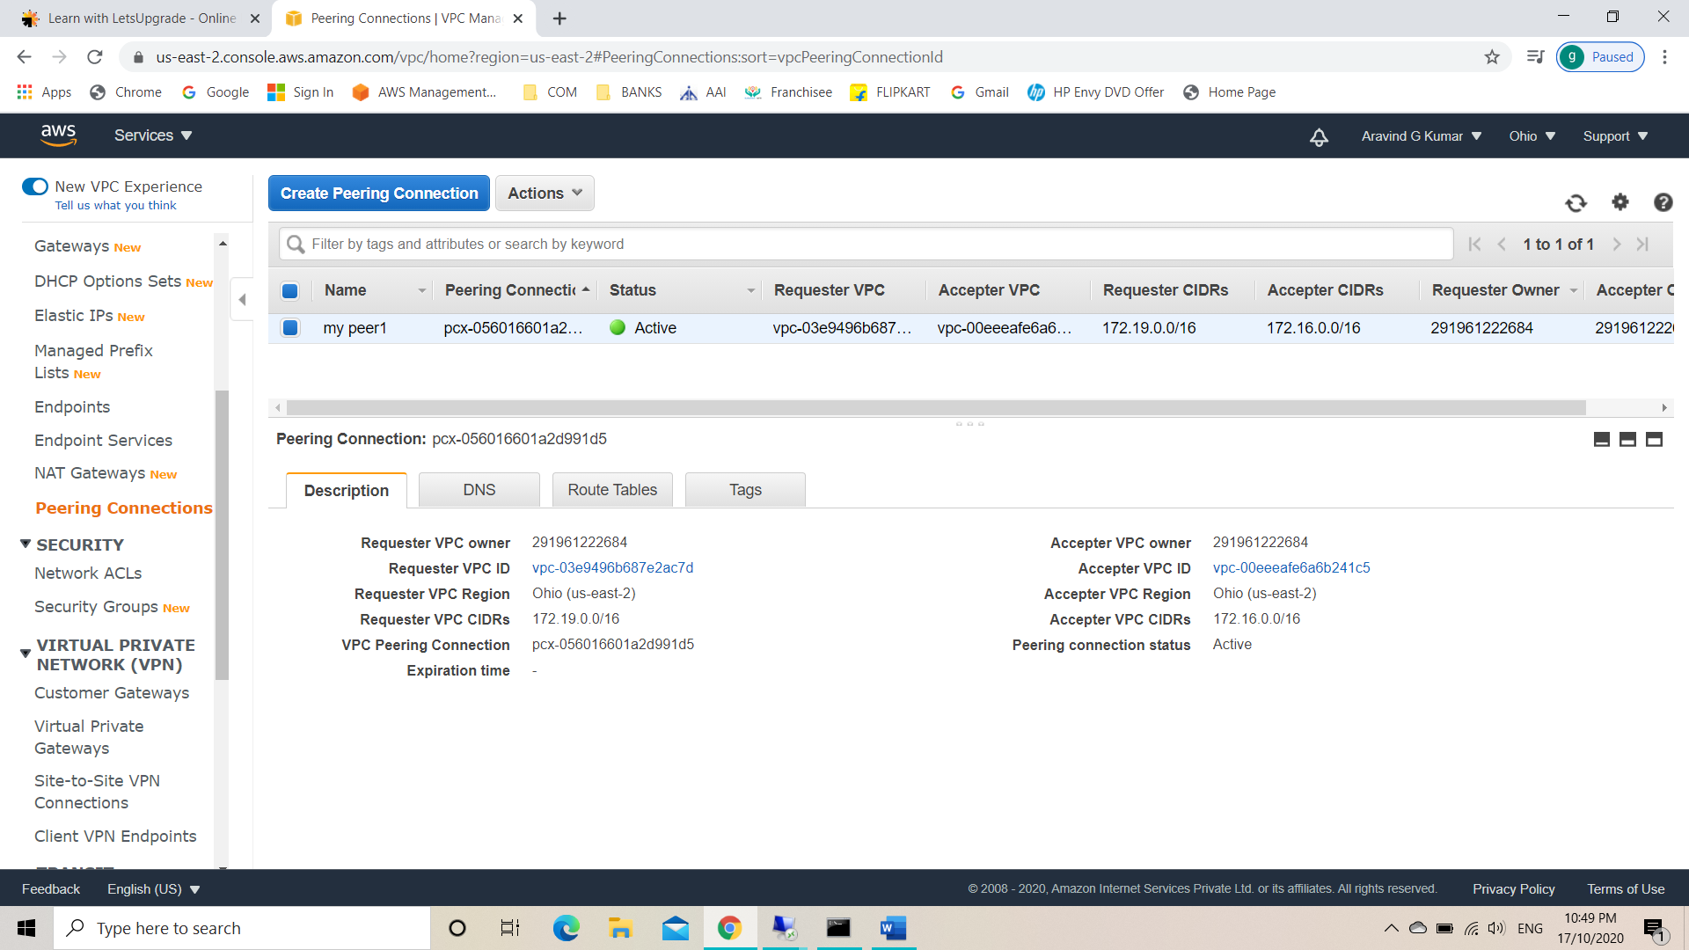

Task 18: Add a new route to the existing two route tables.

* Select my route 1.
* Click on edit routes.
* Edit IPv4 CIDR block to 172.16.0.0/16.

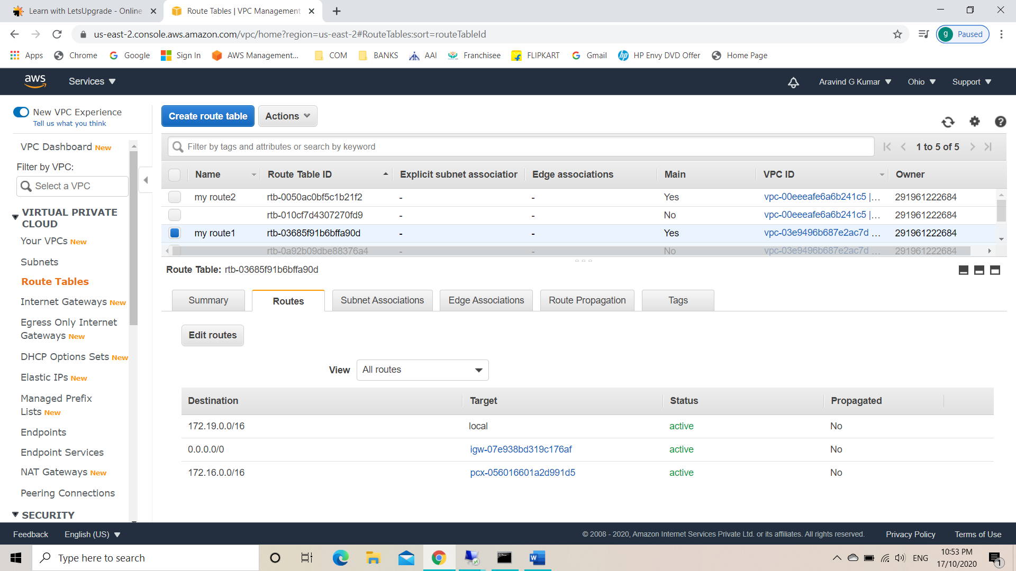

* Select my route 2.
* Click on edit routes.
* Edit IPv4 CIDR block to 172.19.0.0/16.

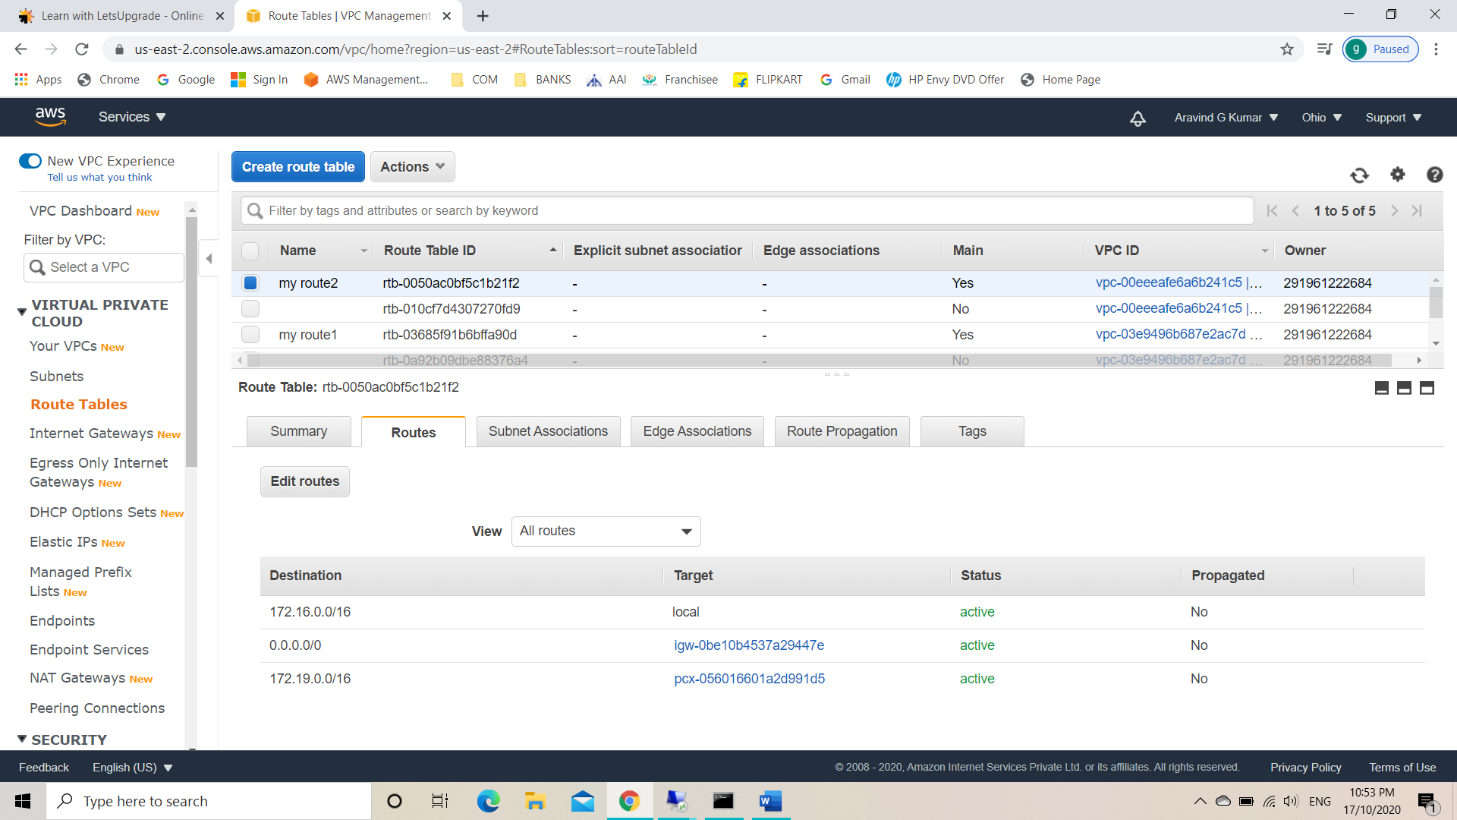

Task 19: Pinging between two virtual instances.

Pinging demo 1 to demo 2 virtual machines using Private IPv4. The pinging was successful.

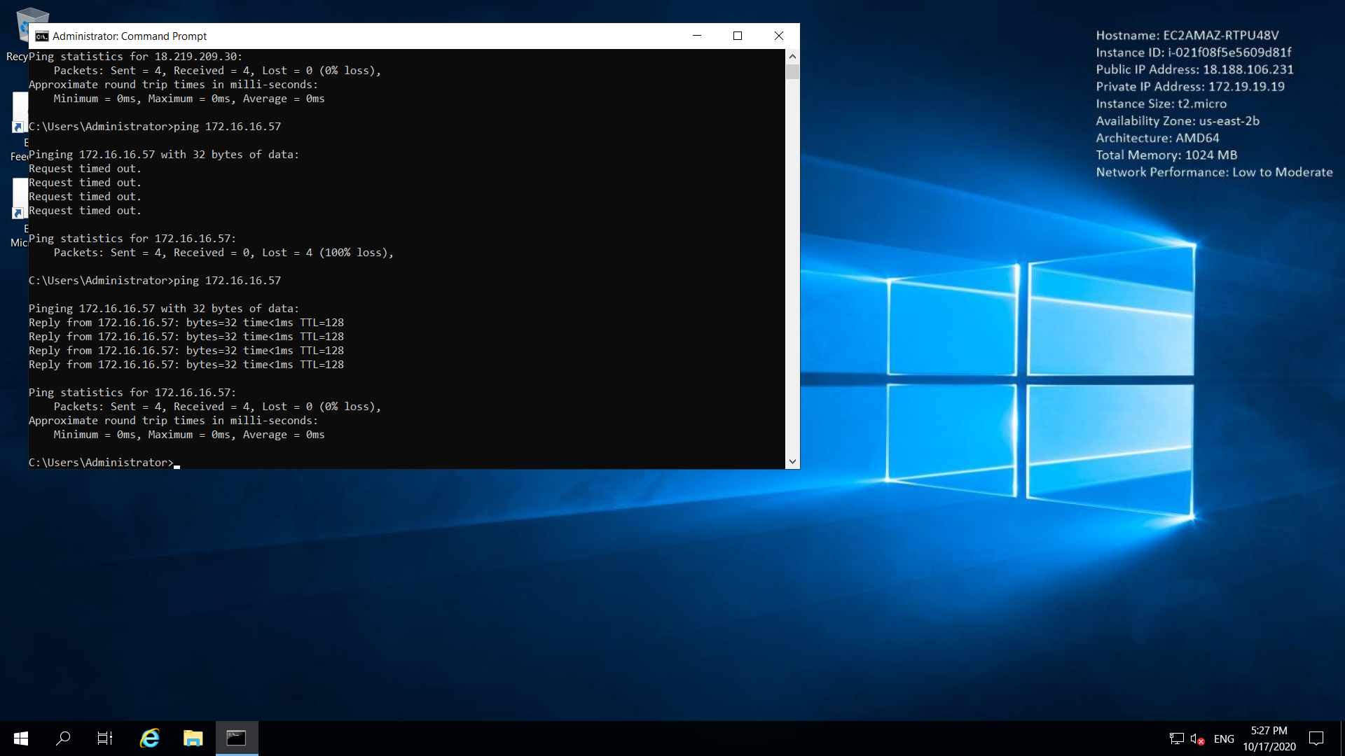

**Project 2: IAM**

Task 1: Creating Users without permissions – IAM password policy check.

* Go to IAM from service tab.
* Click on users.
* Add user.
* Give a name to the user and select both access types.
* Give a custom password.
* Check on require password reset.
* Create the user without adding anything else.

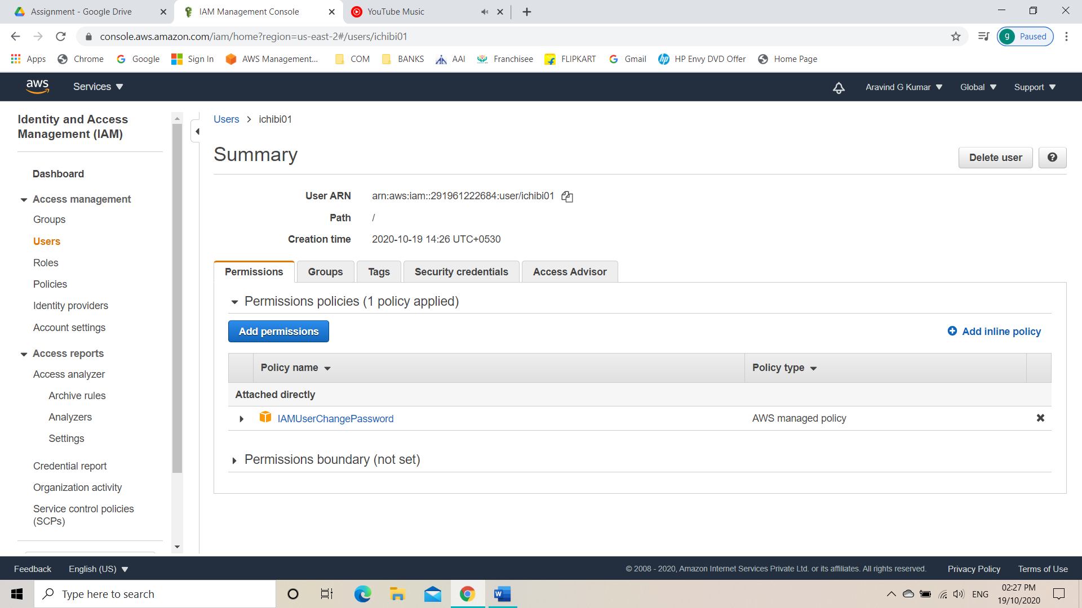

Task 2: Creating Users without permissions – without IAM password policy check.

* Go to IAM from service tab.
* Click on users.
* Add user.
* Give a name to the user and select both access types.
* Give a custom password.
* Leave the require password reset unchecked.
* Create the user without adding anything else.

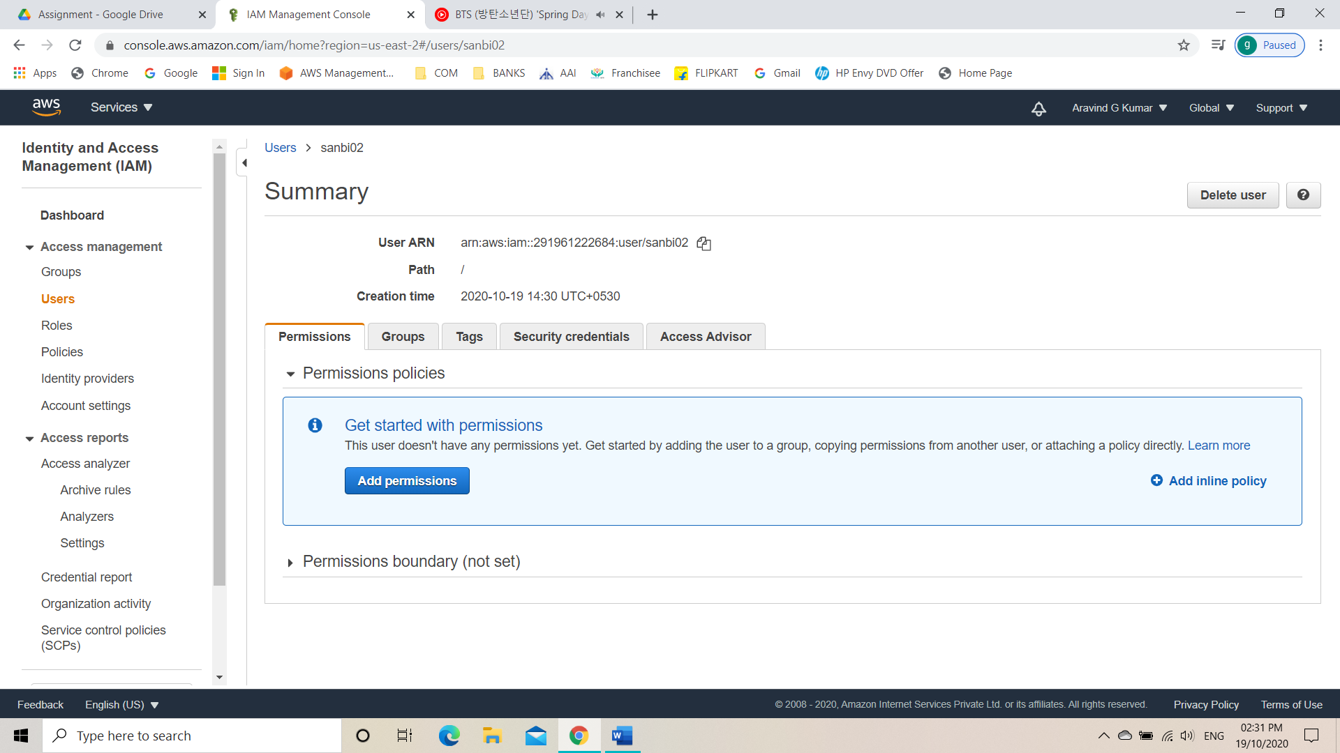

Task 3: Create a user with full S3 access.

* Go to IAM from service tab.
* Click on users.
* Add user.
* Give a name to the user and select both access types.
* Give a custom password.
* Leave the require password reset unchecked.
* Click on permissions and click on attach existing policies directly.
* Attach Amazon S3 full access.
* Create the IAM user.

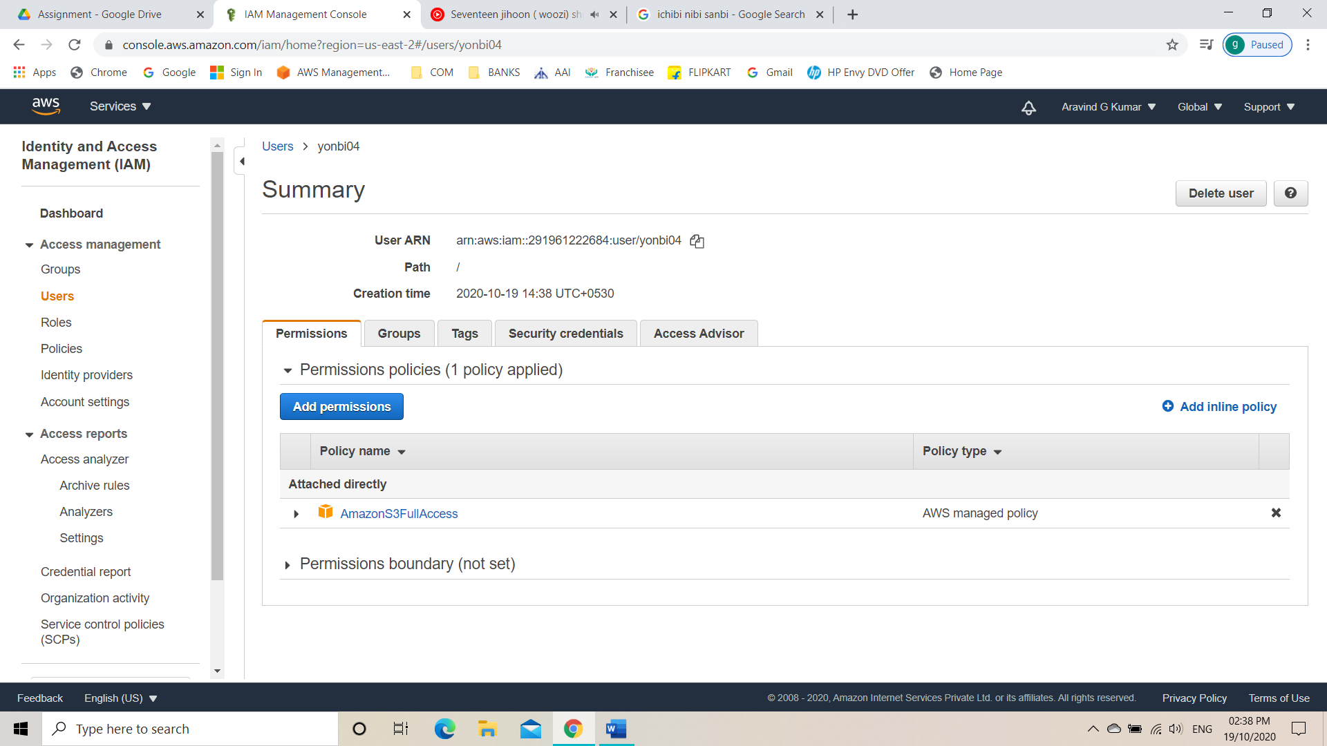

Task 4: Create a group with EC2 full access.

* Go to IAM from service tab.
* Click on groups.
* Create a new group.
* Give the group a name.
* Attach new policy
* Give Amazon EC2 full access.

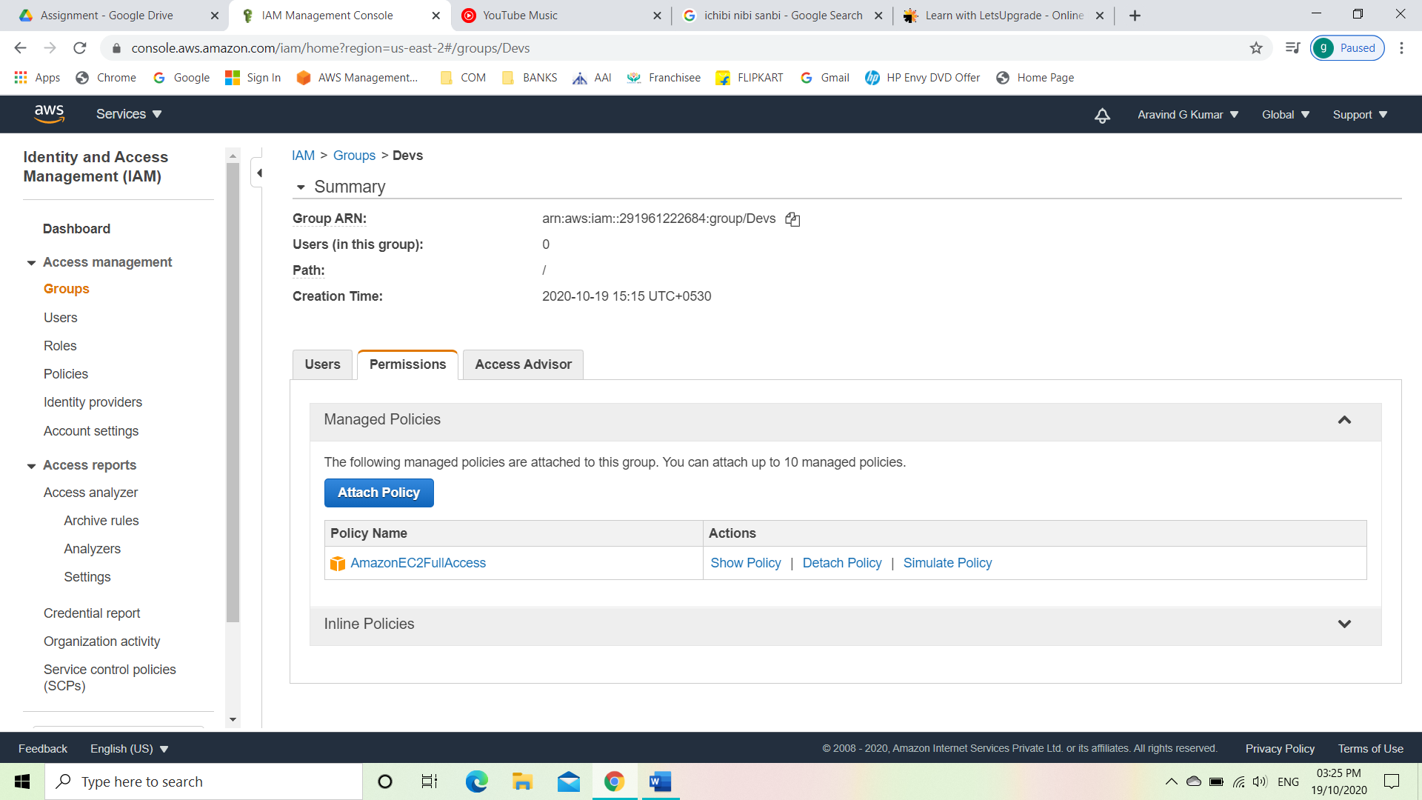

Task 5: Add user to a group and check if the user policy and group policy is reflecting.

* Click on groups.
* Add user to the newly created group.

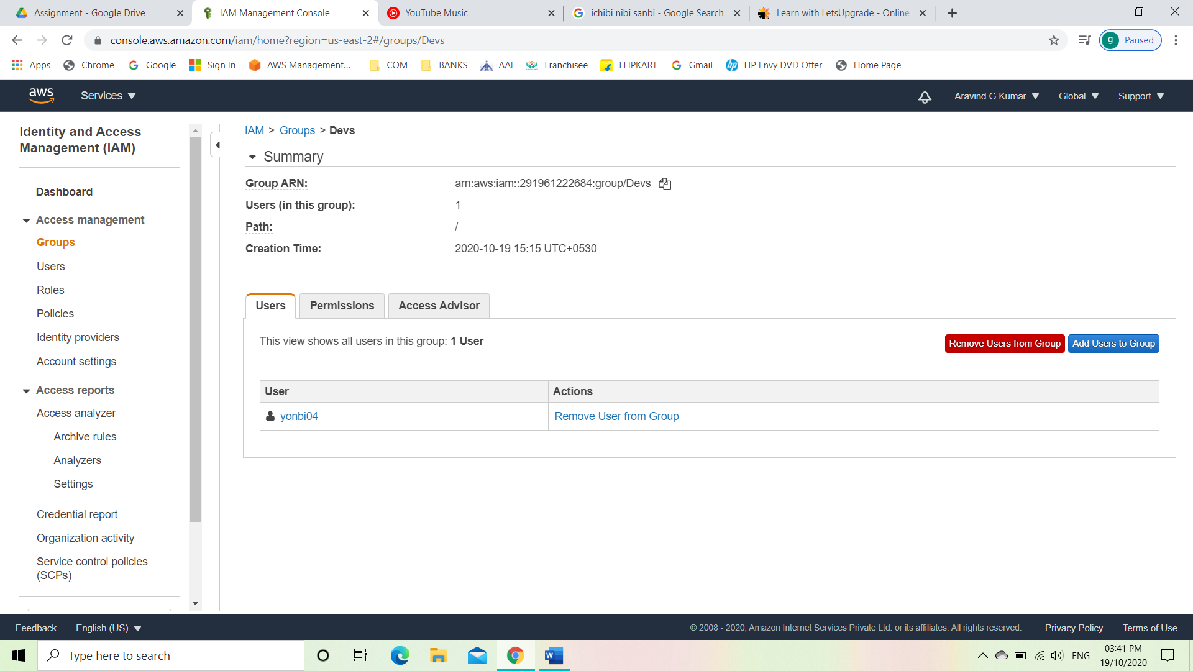

* Checking if the user policies are reflecting.

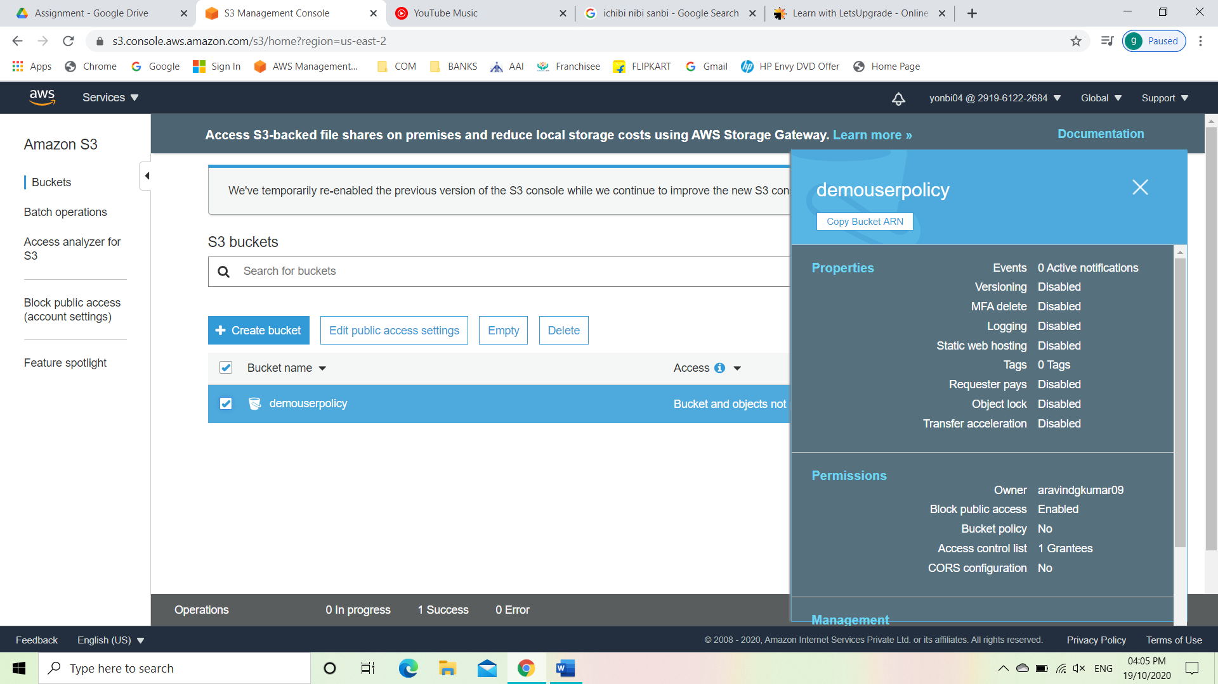

* Checking if the group policies are reflecting.

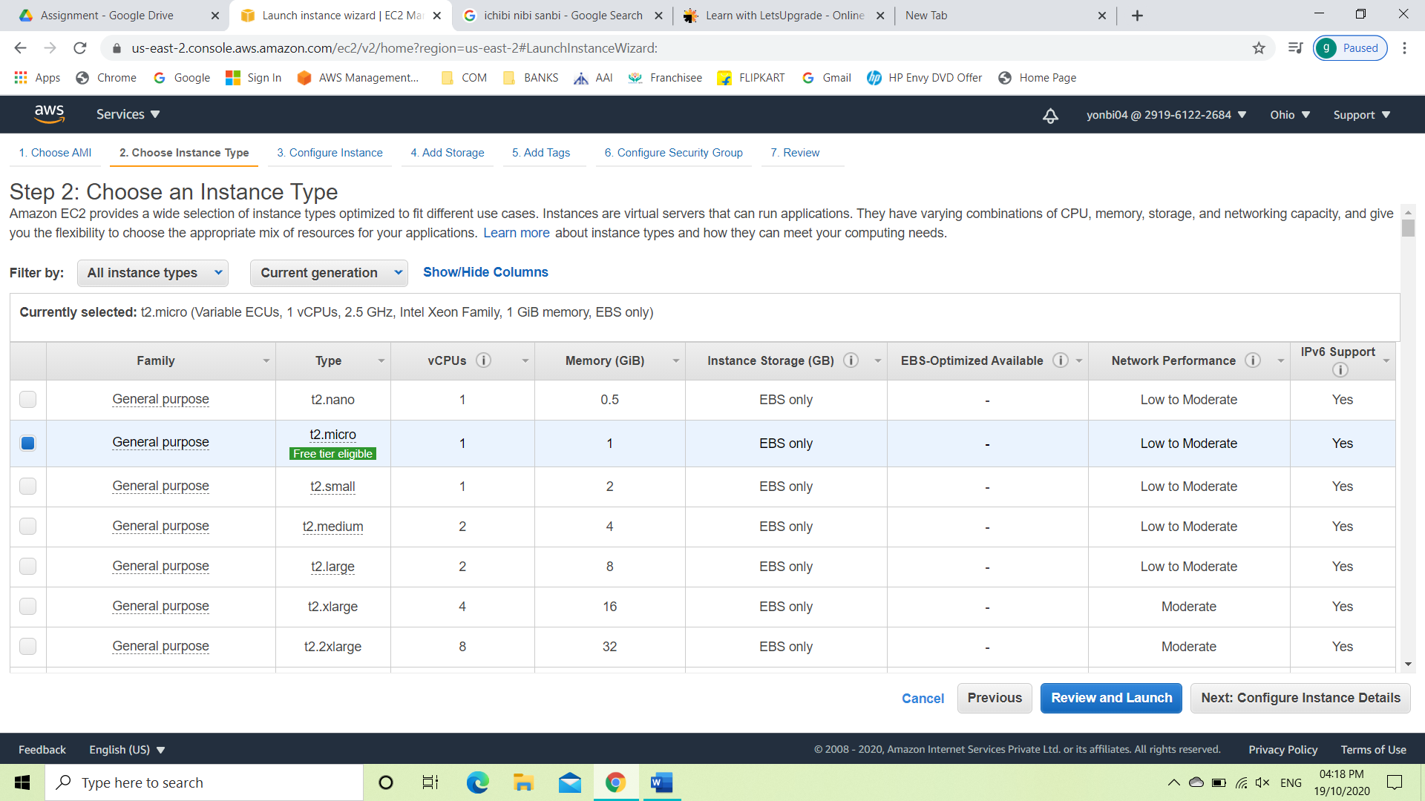

Task 6: Copy policies from existing user.

* Go to IAM from service tab.
* Click on users.
* Add user.
* Give a name to the user and select both access types.
* Give a custom password.
* Leave the require password reset unchecked.
* Click on permissions and click on copy policies from existing user.
* Select the user which has given Amazon S3 full access.
* Create the IAM user.

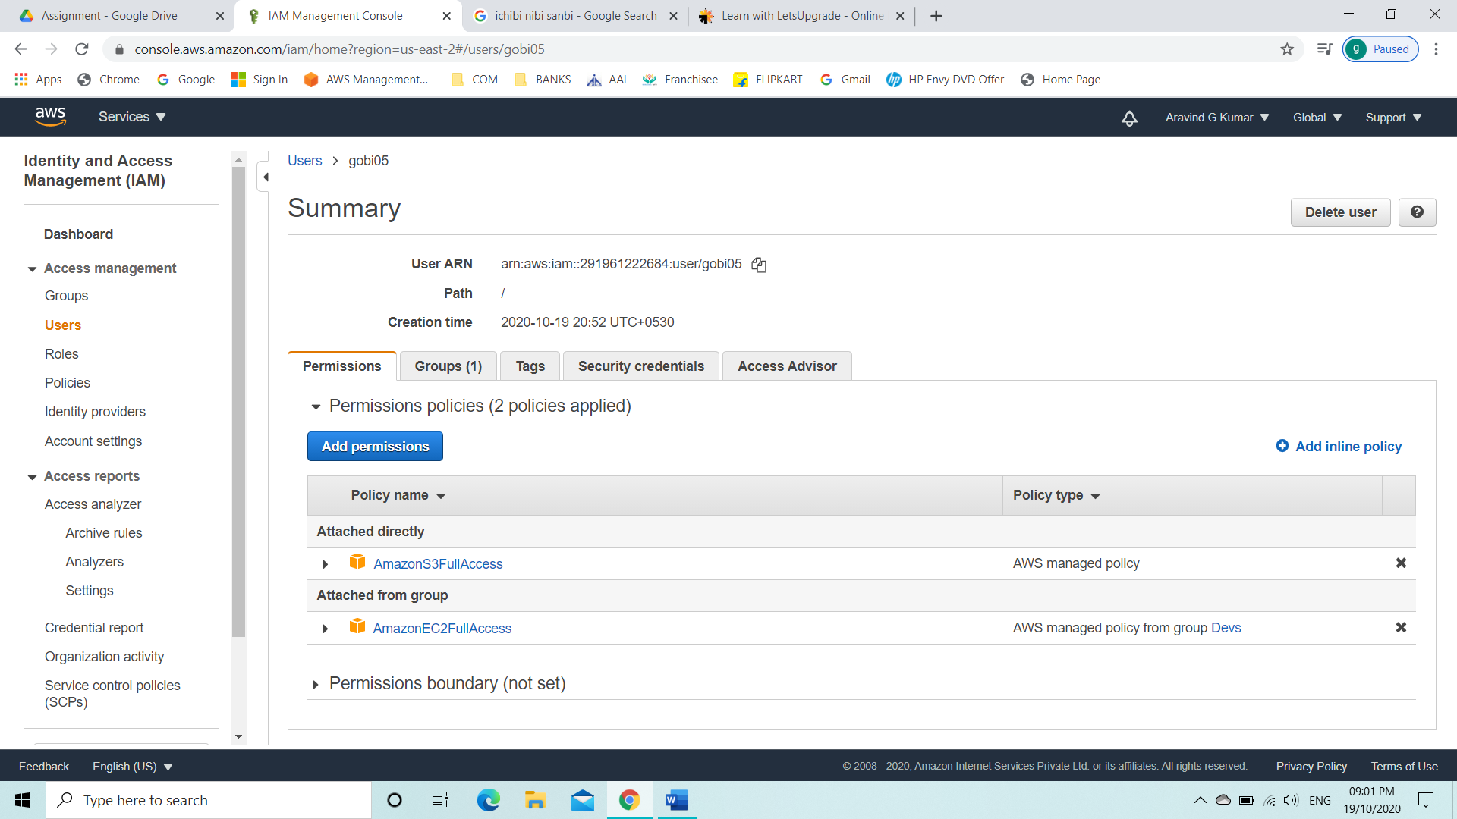

* Login with the new IAM user and see whether the policies are reflecting.
* Check whether the copied user policies are reflecting.

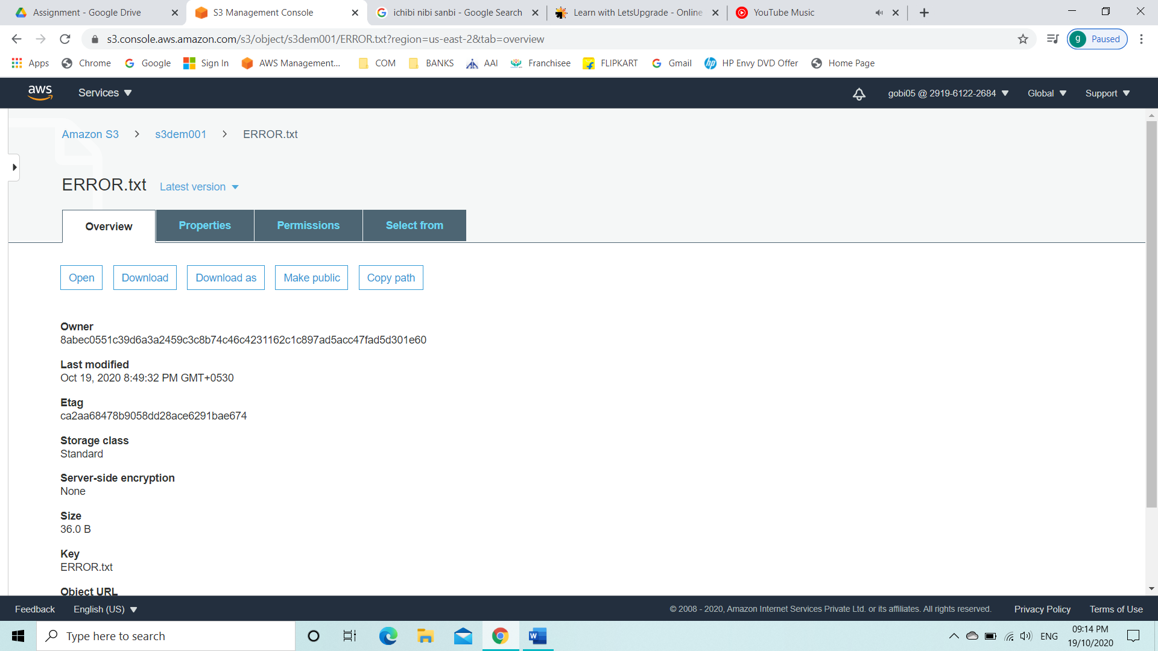

* Check whether the group policies are reflecting. And it is reflecting.

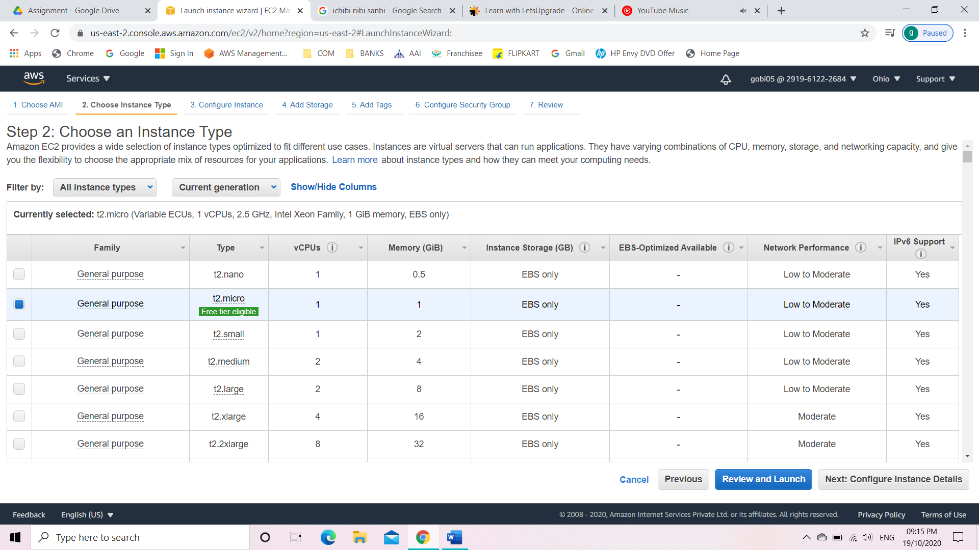

Task 7: Add user to a group in the process of creating a user.

* Go to IAM from service tab.
* Click on users.
* Add user.
* Give a name to the user and select both access types.
* Give a custom password.
* Leave the require password reset unchecked.
* Click on permissions and add user to a group.
* Select the group which has been created.
* Create the IAM user.

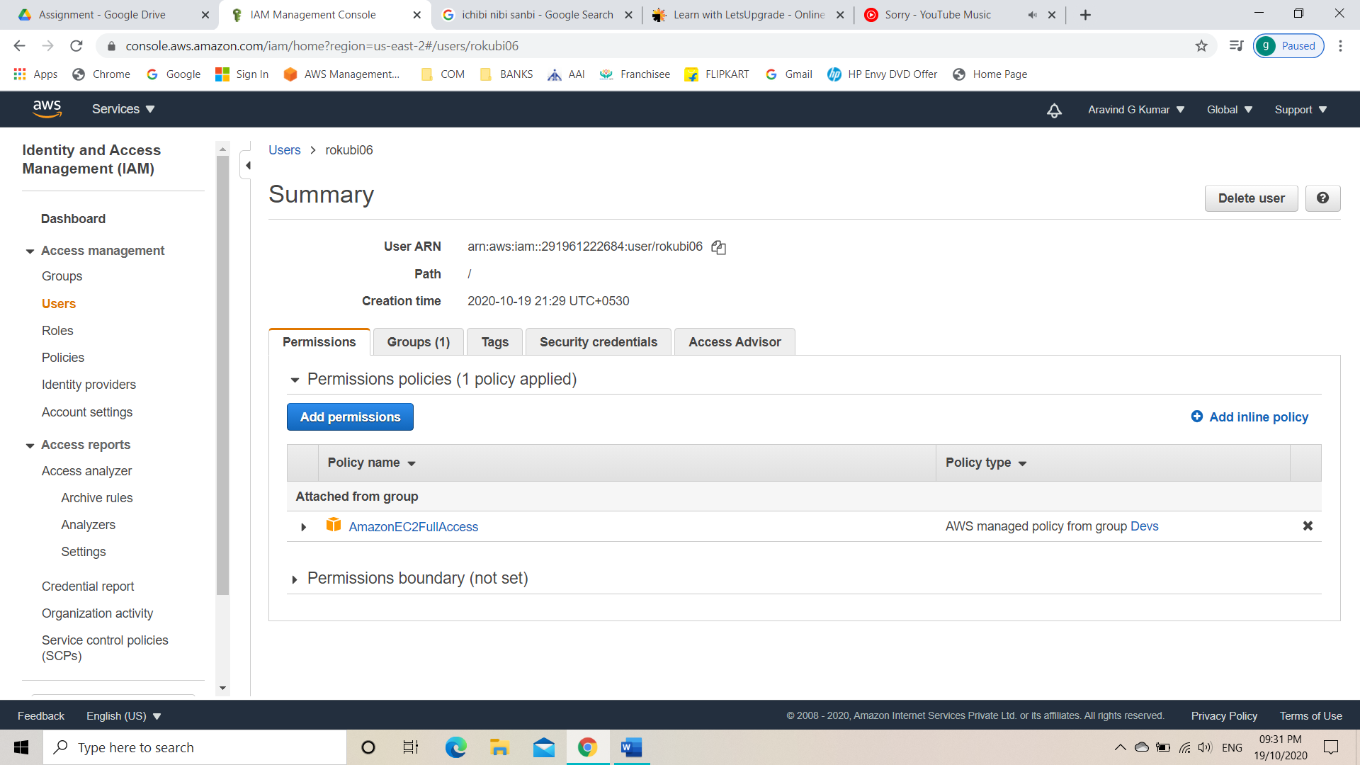

* Login with the new IAM user and see whether the policies are reflecting.
* Check whether the group policies are reflecting.

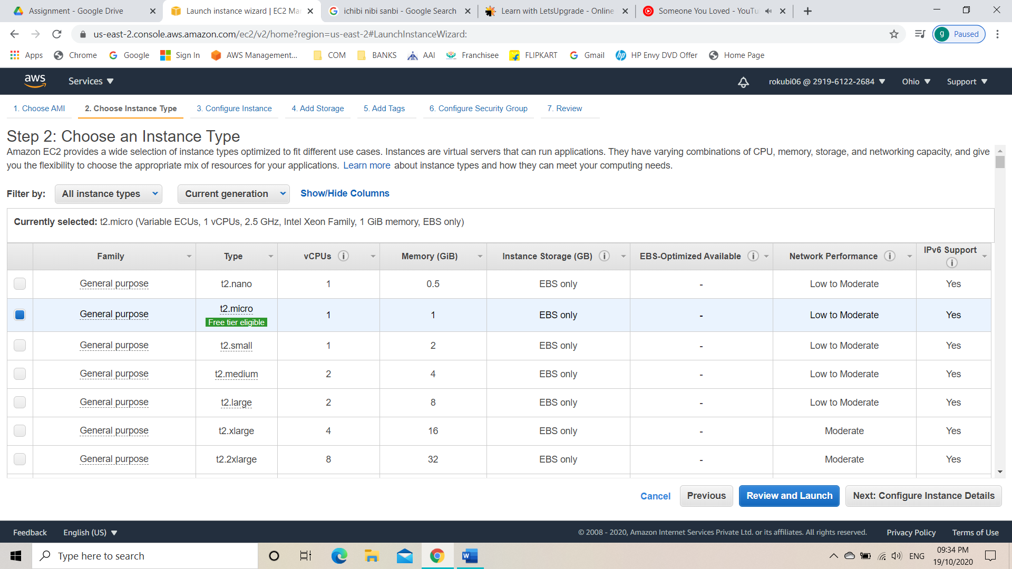

Task 8: Setting a password policy.

* Go to IAM from service tab.
* Click on account settings.
* Select set password policy.
* Set password policy

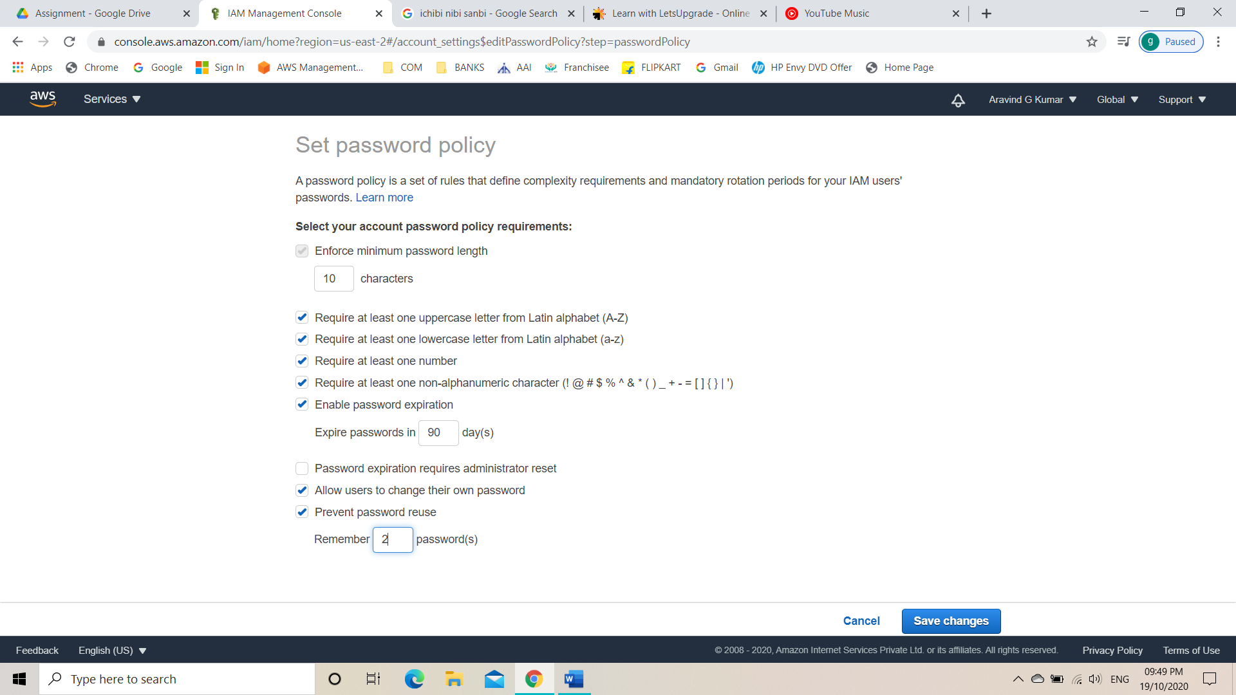

* Create a user and check the password incompatibility error is showing.

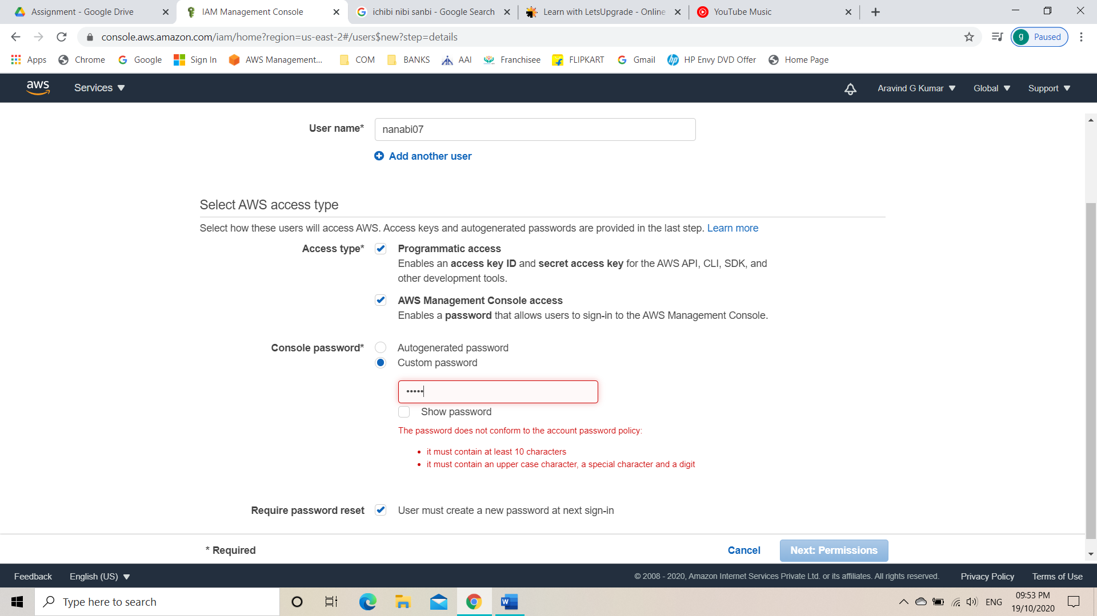

Task 9: Enabling MFA and using a MFA device.

* Go to IAM from service tab.
* Can see MFA on the IAM dashboard or the IAM home page.
* Click on enable MFA.
* Click on activate MFA.
* Select virtual MFA device.
* Click on show QR code.
* Install google authenticator on smartphone.
* Scan the QR code using google authenticator.
* Enter the code that is shown in the mobile screen as MFA code 1.
* Enter the next code on the mobile screen as the MFA code 2.
* Click on assign MFA.

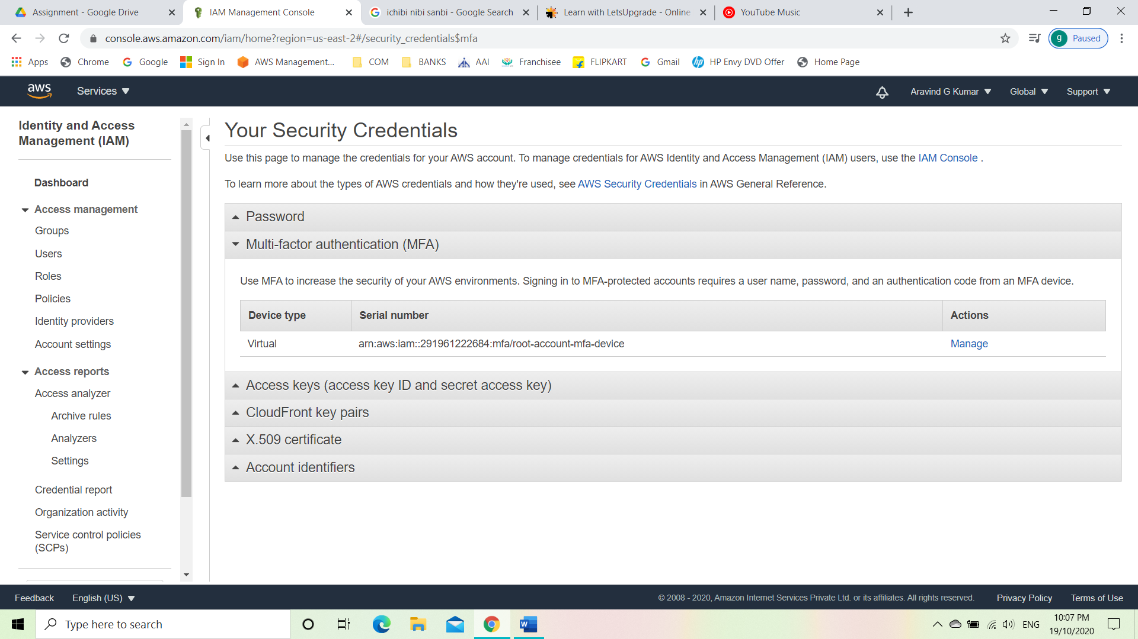

* Log out of the console and again log in as the root user.
* Then wed be able to see it asking for the MFA code.
* Get the MFA code from google authenticator installed on your mobile.

